Learning about Ohm’s law with LEDs
Dr. Gideon Prior
Controls System Engineer
General Atomics Electromagnetic Systems
Name _____________________
Today we will be building a circuit to light up a light emitting diode (LED). In this lab we will learn about electrical current, voltage and resistance by measuring these quantities in the circuit that we build. Circuits are drawn by engineers using symbols for each circuit element. The collection of these symbols and the wires used to connect them together is known as a schematic. Here are a few common schematic symbols.

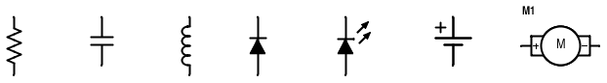
Resistor Capacitor Inductor Diode Light Emitting Diode Battery DC Motor

The circuit we are going to build today is represented below. Can you find in your lab materials the circuit elements needed to build this circuit?
The first thing we will need to do is to measure the value of our resistor. Resistance is something that reduces the flow of electricity and having the right value resistor in our circuit will ensure we get enough electricity flowing in our circuit without being so much that we burn up our LED. Turn your multi-meter to the resistor setting (sometimes it will look like this symbol Ω). Put the multi-meter probes on each side of the resistor and measure its value. Record your measurement below.

RESISTANCE _____________________ Ohms
Now we are ready to construct our circuit using the breadboard that has been given to you. Shown below is a picture of a breadboard, as well as what the back would look like if you took the back covering off. The rows of metal strips connect all of the components in the same row together.
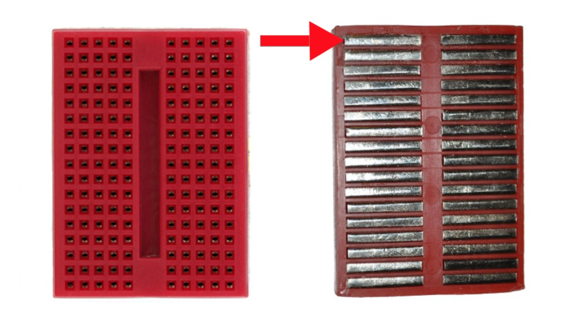

Build your circuit by choosing a row near the top of the breadboard to place the longer pin on your LED. An LED needs to be plugged in in the right direction for it to work. Here is a picture to help you remember. The longer pin is the one we will connect to the positive ( ‘+’ ) terminal of the battery.

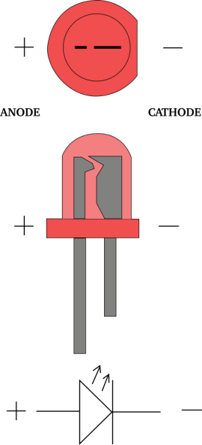

Now choose the next row down and put in the shorter end of the LED. Take your resistor and also plug it into the same row.
All that is left for us to do now is to connect the battery. Take your battery and connect the battery clip. Now using the alligator clips and wires, attach the wire from the positive (‘+’) terminal of the battery to the longer LED pin, and connect the wire from the other terminal (‘-‘) to the end of the resistor. You should see your LED light up.
Now let’s take some measurements.
Here is the schematic of the circuit we have just built.
The voltage measurement we need to take is the voltage of our battery. Turn on your multi-meter, set it to ’V’ for volts, and put the multi-meter’s probes on the battery. With the battery connected, put the red probe on the battery terminal marked with a ‘+’ and the black probe on the battery terminal marked with a ‘-‘. Record your results below.

BATTERY VOLTAGE _____________________ Volts

} measure the voltage here, across the diode.
Take your multi-meter and measure the voltage across the light emitting diode. Record the voltage below.

LED VOLTAGE _____________________ Volts
Now, let’s figure out what the voltage should be across the resistor.
Voltage across the resistor = Battery Voltage – LED voltage
Record your estimate of the resistor voltage below
INDIRECTLY MEASURED RESISTOR VOLTAGE _____________________ Volts
Let’s see how close you were. Take your multi-meter and measure the resistor voltage. Record it below.
DIRECTLY MEASURED RESISTOR VOLTAGE _____________________ Volts
How do the two values compare?

In the last part of this lab, we will use a measurement of the current flowing in our circuit to find the voltage across the resistor. Ohms Law is an equation that relates voltage, current and resistance. It is given as follows
Voltage = Current X Resistance
To measure the current in the circuit we need to ‘break’ the circuit, which means we need to disconnect two of the components and put the multi-meter between them. Let’s disconnect the negative terminal of the battery and the bottom of the resistor. Now your multi-meter is in series with the circuit.
Now connect the battery wire that you just disconnected to one multi-meter probe, and the bottom pin of the resistor to the other one. Set you multi-meter to ‘A’ for Amps, and record the value it gives you.

MEASURED CIRCUT CURRENT _____________________ Amps
Now use Ohms Law to find the voltage across the resistor. Record your answer in the space below.
Voltage across the resistor = Current through resistor X Resistance

ESTIMATED RESISTOR VOLTAGE _____________________ Ohms
How close is this value to your measurement of the resistor? Can you think of any reason why they are not exactly the same?

